**#Python program to show the concept of map and lambda**

**#Using map**

def add_five(x):

temp=x+5

return temp

nums=[11,22,33,44,55]

result=list(map(add_five,nums))

print(nums)

print(result)

**OUTPUT**

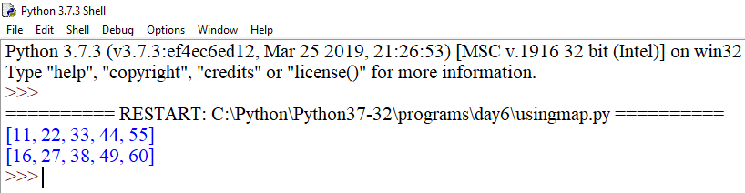

**#Using lambda**

print('-'*40)

num=[11,22,33,44,55]

result=list(map(lambda x:x+5,num))

print(num)

print('After use of lambda in map:',result)

**OUTPUT**

